xtalPiMS Structural Memo
Overall Structural 1
xtalPiMS Web 1
xtalPiMS BusinessAPI 2
➢ Beans and service interface 2
➢ Other packages 2
➢ General Structural 3
➢ PlateDB Implementation 3
➢ PiMSDB Implementation 4
o Implementation Package 4
o DAO package 4
o General Structural 5
Test cases 5

Overall Structural

xtalPiMS Web
xtalPiMS BusinessAPI
xtalPiMS PlateDB Impl
Plate
DB
User
DB
xtalPiMS PiMS Impl
PiMS
DB

xtalPiMS Web
https://cselnx4.dl.ac.uk/svn/pims/crystallization/current/XtalPiMS_Dev
- xtalPiMS Web is the web front end provides the user interface functions for interaction with the user.
- The technology used is JSP, javascript, servlets. Much of the display is done using the Yahoo User Interface Library (YUI v 2.4.1) and data is obtained using AJAX calls (http GET) to Servlets with the data being returned in JSON format.
- There is a generic table javacript object (DataTable) which is populated in a standard way.
- Nearly all the data that is current displayed comes from the View classes of the Business API and is either displayed as a table or as details followed by other tables providing the links to other things (e.g. plate experiments through to inspections, annotations etc.

xtalPiMS BusinessAPI
https://www.pims-lims.org/svn/pims/crystallization/current/XtalPiMS_BusinessAPI

Beans and service interface
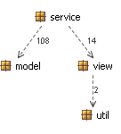
- There are two sets of beans:
  - Model Beans in packages:
org.pimslims.business.core.model, org.pimslims.business.crystallization.model;
  - View Beans in package:
org.pimslims.business.crystallization.view. They can be converted to Jason Objects
- Service interface are in packages:
org.pimslims.business.core.service, org.pimslims.business.crystallization.service
Service interface is used to create, read/search, update, delete (CRUD) model beans and search view beans.

Other packages
- Criteria package is used for search beans by service

General Structural
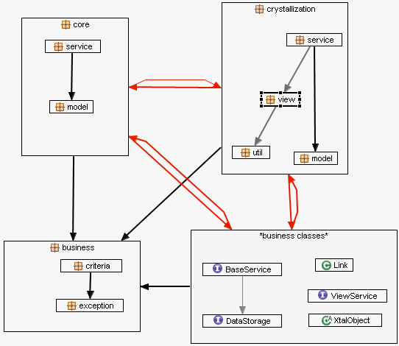

The implementations of the Business API serve two purposes
  - As a way of using the GUI on top of a database (or set of databases)
  - As a way of transferring data from one database (or set of databases) to another through the medium of the Business API objects.
The service interface in BusinessAPI currently has two independent implementations:

PlateDB Implementation
https://cselnx4.dl.ac.uk/svn/pims/crystallization/current/XtalPiMS_BusinessAPI_PlateDBImpl

PlateDB is the existing database for storing crystallization plate information for the OPPF. An additional database, Nautilus, provides the sample and plate set up information (some of which is copied into plateDB).
The PlateDB Implementation of the Business API only provides the elements of it that it knows about and has been a proving ground for both the Business API definition and the GUI development. User information comes from the User Management Application userDB database, so the user information is largely independent of plateDB.
Database connectivity is achieved using JNDI definitions.
In most cases the findViews functions in each of the services have been implemented using raw SQL in order to get the speed and responsiveness to the users through the GUI – in many cases one of the problems with the Business API is that it requires large joins in the underlying tables, then converting from the database objects to the business objects and then through to the JSON objects to give to the GUI, this three stage translation needs to be as quick as possible at all stages. There is a notional 3 second rule – a page should load for the user in under 3s, so everything has to be fast – helping this includes paging, filtering etc at the database level and the Business API Criteria definitions help considerably with this.
It will be noted that not all the functions of the Business API have been defined for the plateDB implementation – this is due to the fact that they have not so far been needed at the GUI level or the machine integration level that has been used so far. This does not mean that they should be removed from the Business API, but that this should be a consideration in the future.

PiMSDB Implementation
https://www.pims-lims.org/svn/pims/crystallization/current/XtalPiMS_BusinessAPI_PIMSDBImpl
This implementation is using PiMS database (v33) and persistence layer (pims-dm-hb.jar)
In theory, PiMS database should store same information as PlateDB+UserDB but in different Structural.
However, at the moment, not all information in PlateDB can be stored into PiMS and PiMS can not be used as UserDB in xtalPiMS Web. This is due to PiMS database has different schema, even though a lot of changes have been done to PiMS DB in this direction.

DAO package
service interface of BusinessAPI
Implementation
Package
pims-dm-hb.jar
ModelBean’s DAO
ViewBean’s
DAO

Implementation Package
This package, org.pimslims.crystallization.implementation, implements service interface of BusinessAPI by using DAOs.

DAO package
This package translate PiMS Objects to/from xtalPiMS Objects, it include two packages:
  - org.pimslims.crystallization.dao, for CRUD xtalPiMS Objects, ModelBeans
  - org.pimslims.crystallization.dao.view, for search xtalPiMS Objects, ViewBeans

General Structural

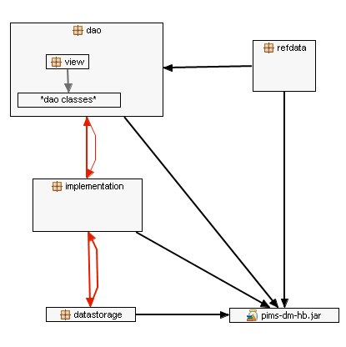
- refData package include tool to add essential reference data
- dataStorage package implements DataStorage interface of BusinessAPI

Test cases
There are 2 layers of test cases:
- Abstract test cases in xtalPiMS BusinessAPI (under folder /test)
These testcase can not be run on their own as the they are using interface only. In theory, all these tests should be successful in plateDB or PiMS DB implementation. But, due to lack of some functions, like create, in plateDB implementation, not all tests success in plateDB.

- Tests in plateDB or PiMSDB implementation layer
For PiMS impl (under folder /test), there are 83 tests which covering 59.5% of pims impl’s source code and 29.3% of xtalPiMS BusinessAPI’s source code. All of them should be successful.

